# 第一节：Introduction

## Introduction

What you will learn?

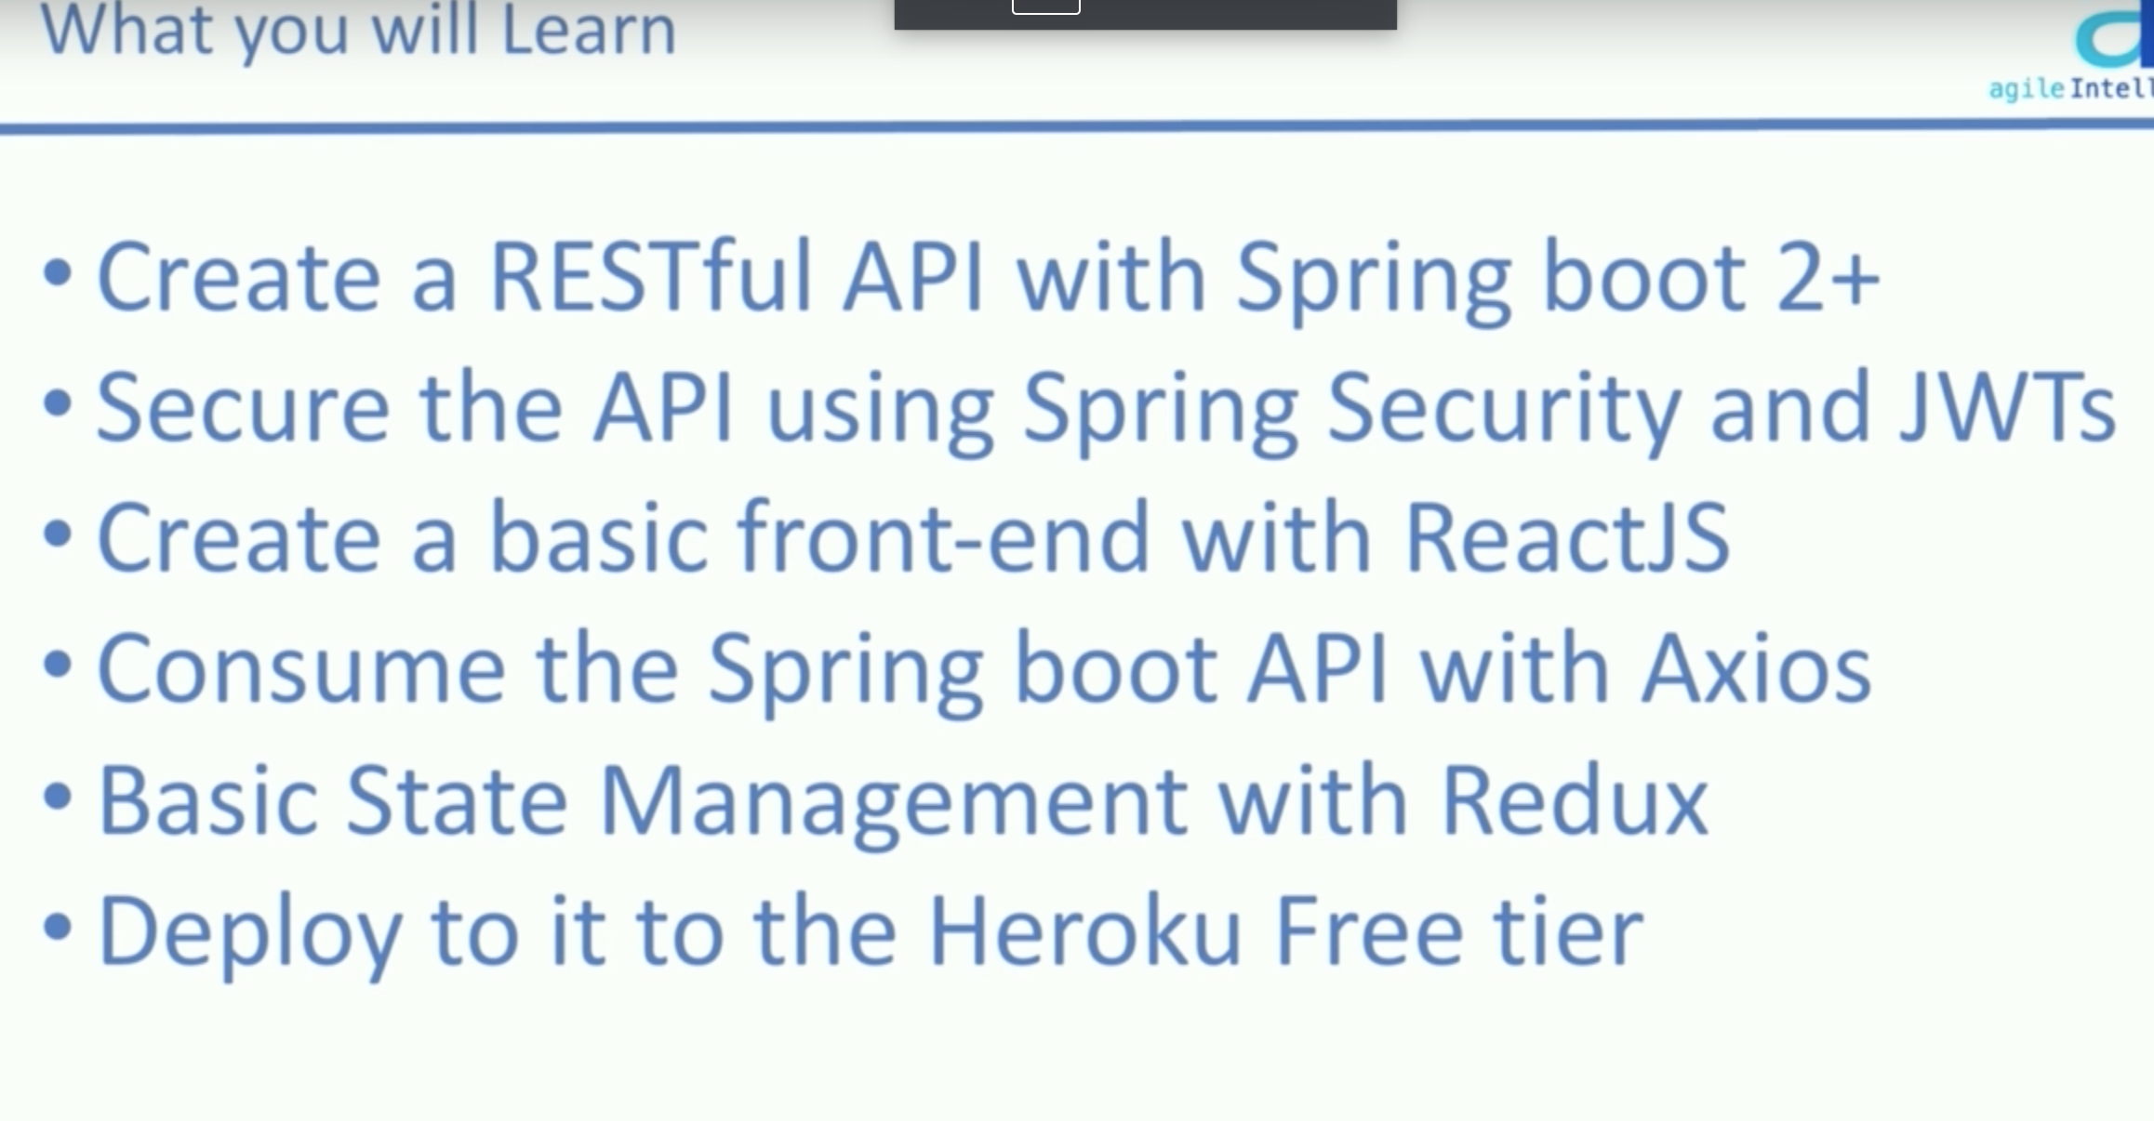

requirement

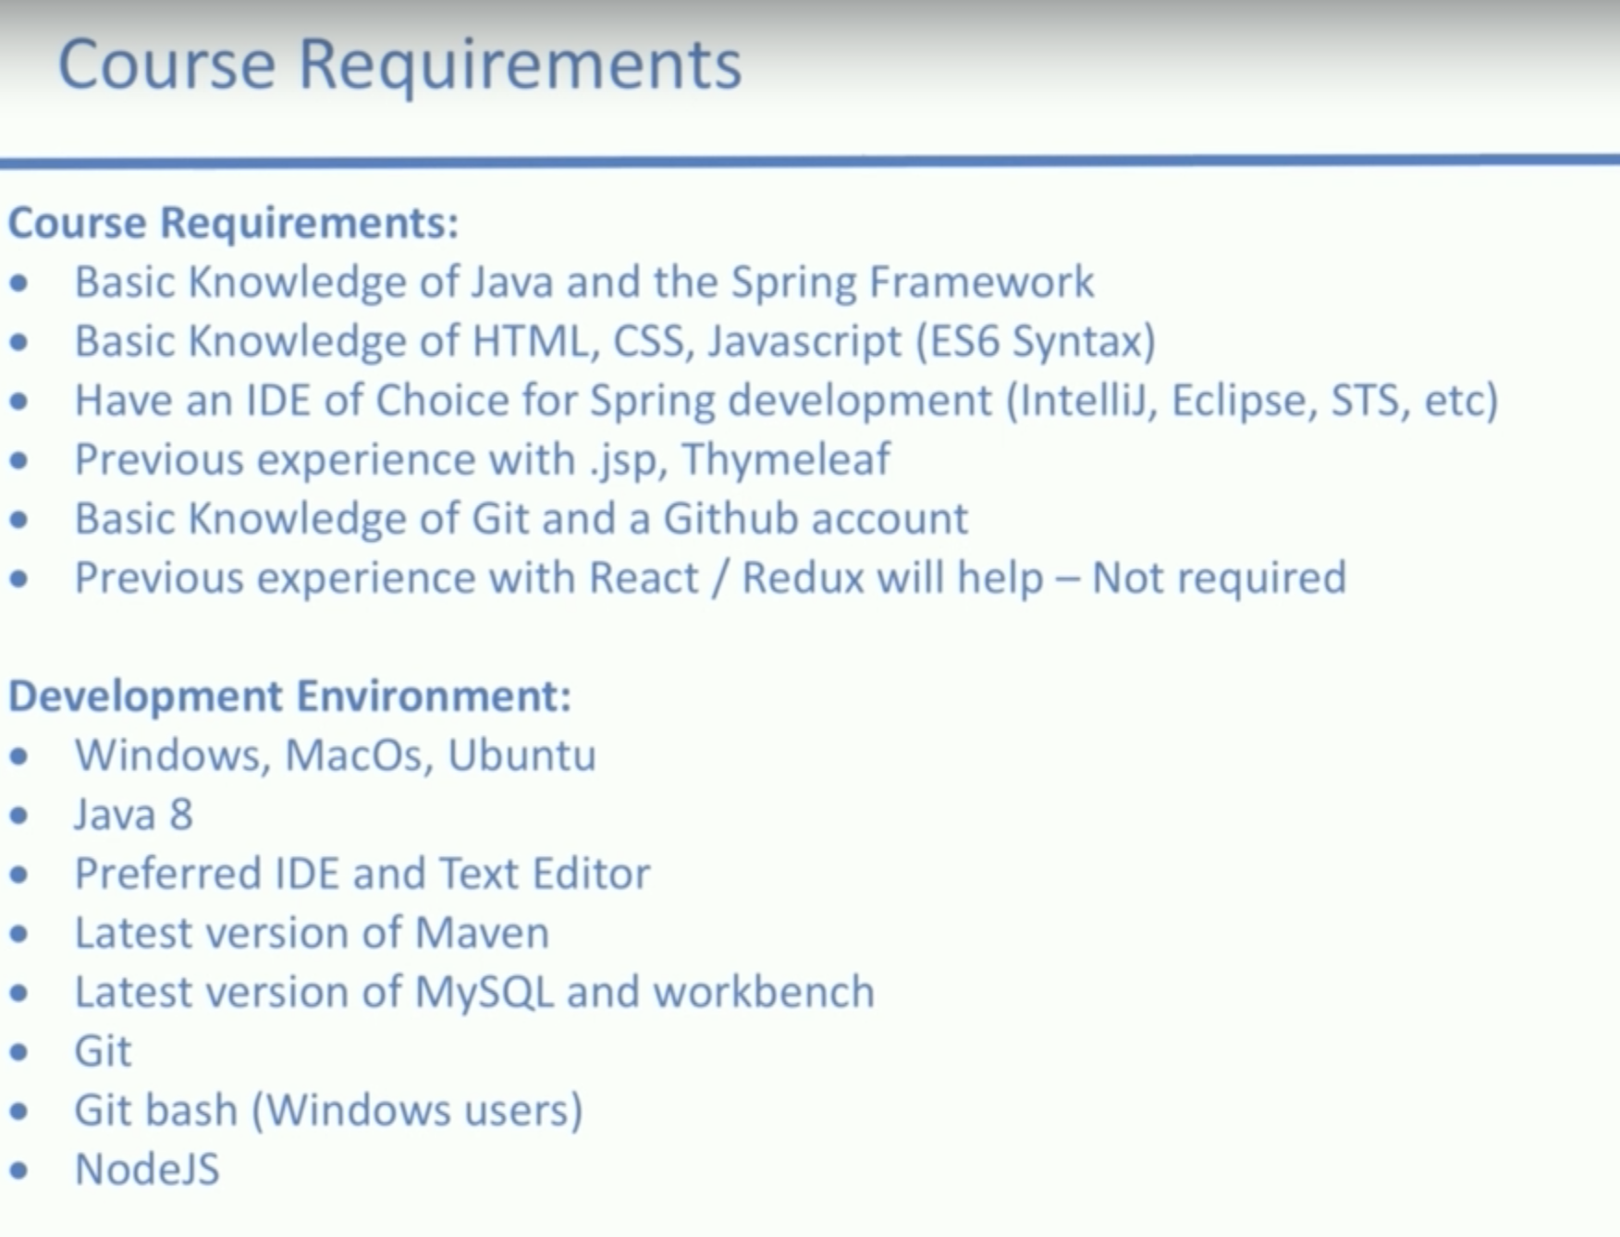

# 第2节: Spring backend – Basic CRUD operation – Project

## Folder structure and Github setup

First create a spring boot starter project wit the dependencies below

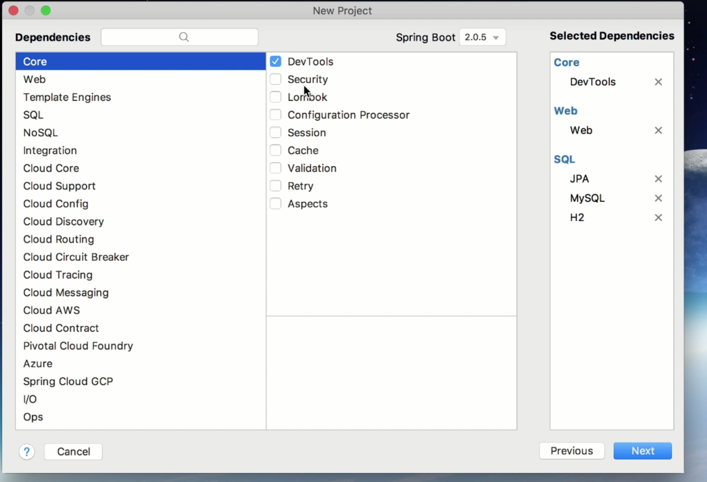

don’t forget to import Maven as well.

Then create a new project in your github account and make your first commit and push it.

## Project object & project repo - Branch 1

And also the getters and setters for all the fields.

The reason why the field projectIdentity is not named as projectId is that we are gonna connect this entity with some other entities afterwards, spring will automatically assign a field named projectId to the table, we don’t want the ambiguity.

Then we start the project and check the h2 database at localhost:8080/h2-console

We have this console since the h2 and devtool setup been done before.

**Why use h2 here?**

**Based on his lecture, we can start development quickly without setting up mysql, not sure how’s it work like.**

After setting up the database and entity, we need to set up the project repository interface using @ CrudReposotory annotation(the so-called DAO layer).

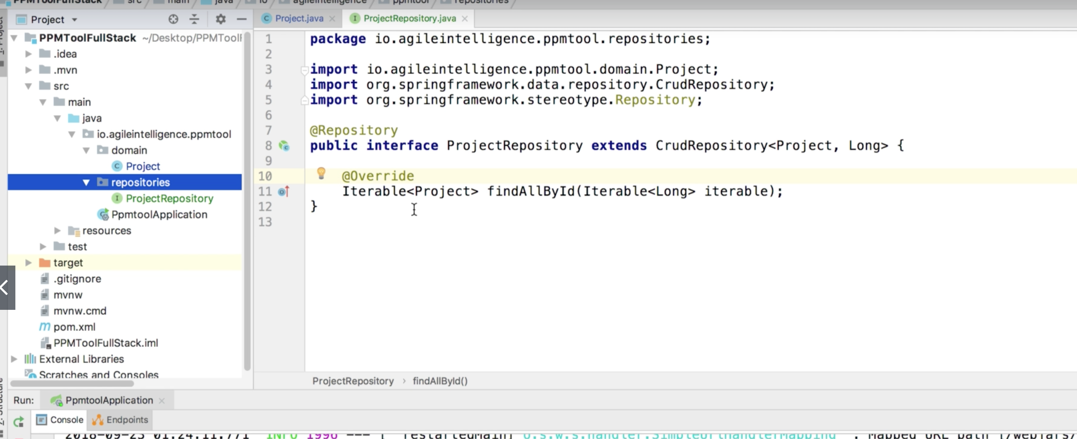

## Project Service & Project Controller – branch 2

Create service packages where we are gonna put all services, we separate the controllers to another layer so that we don’t need to put all logic in controllers.

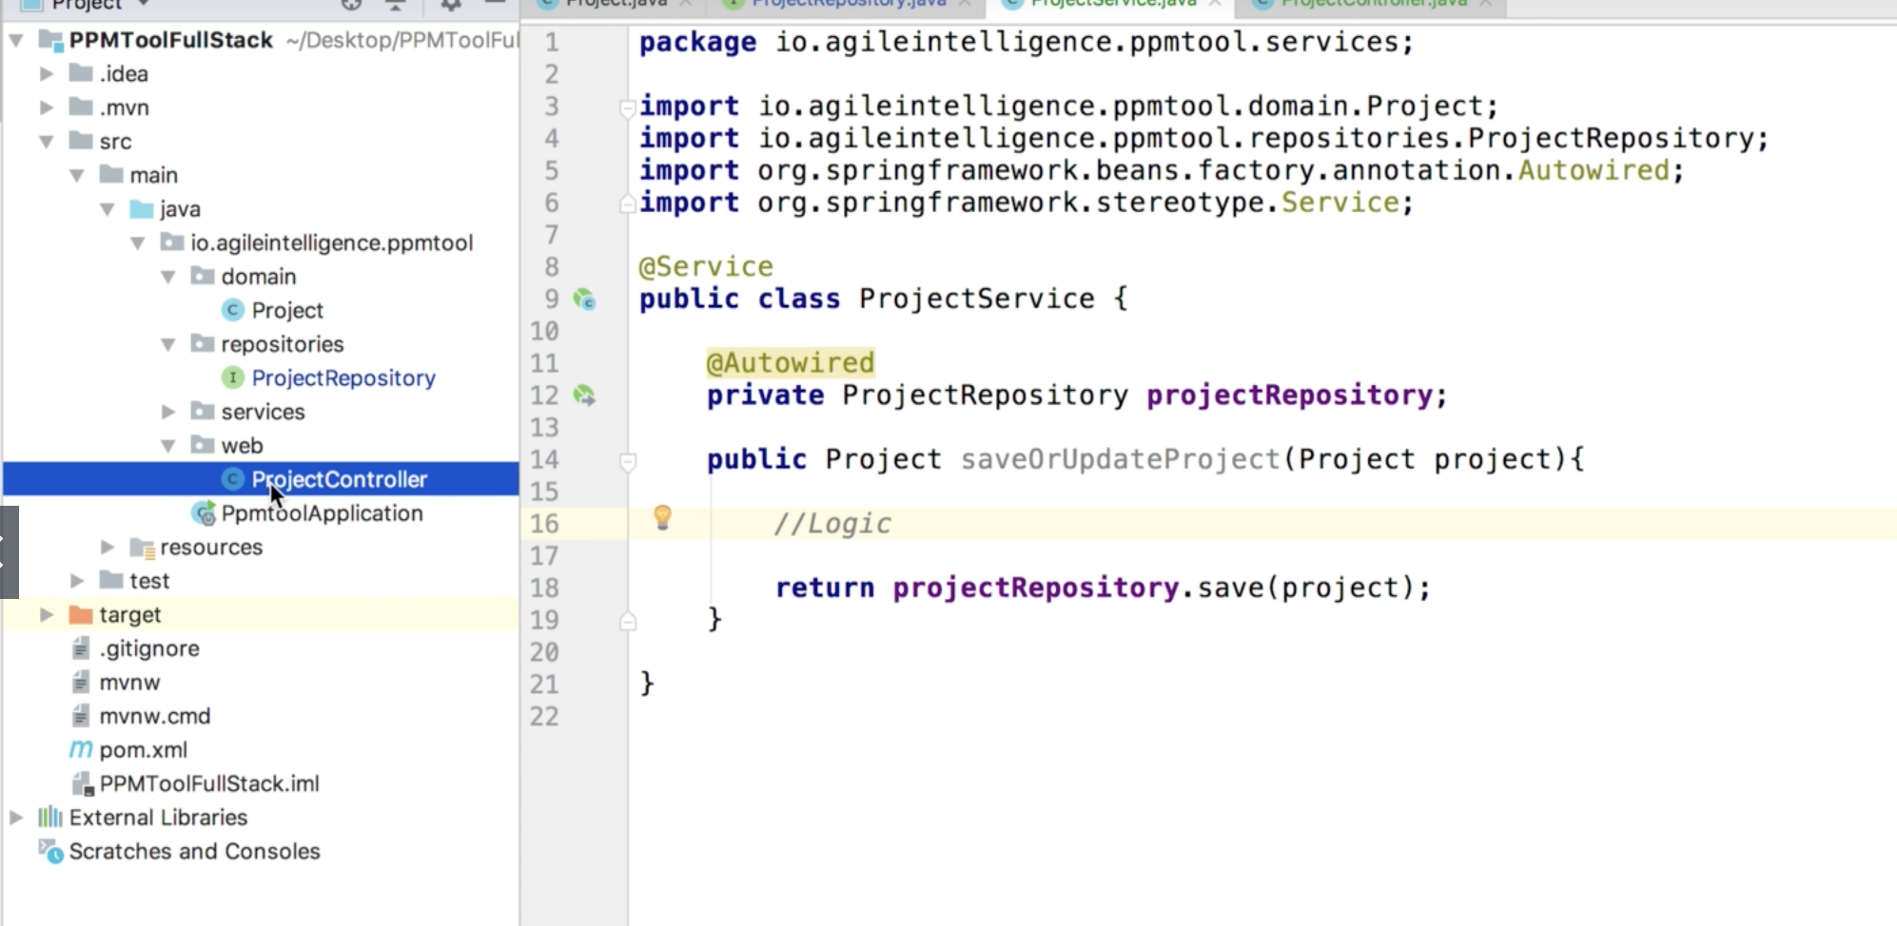

Then we create our controller layer, here the response entity can let us have more access to response and set up the response json more clear.

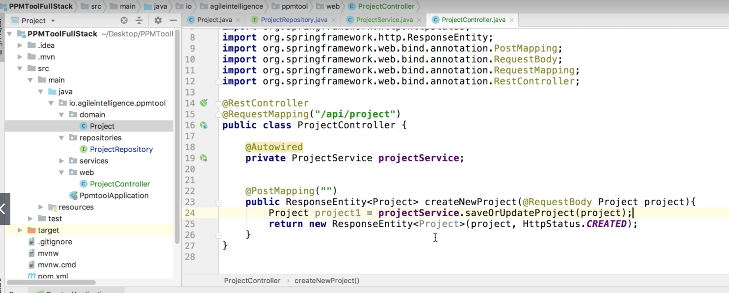

## Set up project object validation

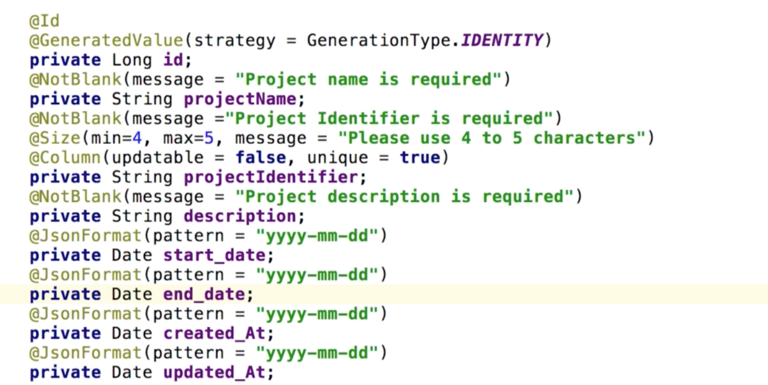

Use some spring annotation to standardize the field values and restrictions.

## Project object validation part 1

After we setting up the restriction to database fields, the backend would throw the exception if we pass in something not following the validation rules.

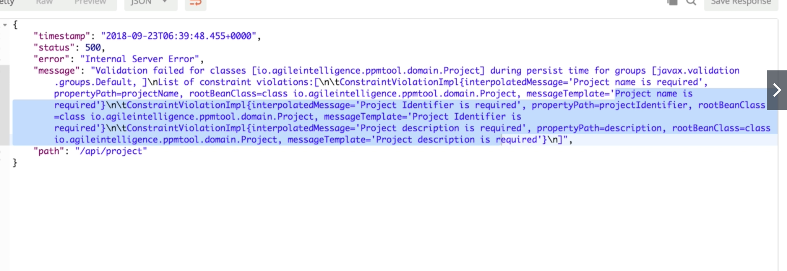

But it’s not readable, we are gonna set up a more clear response.

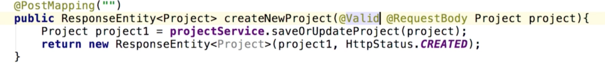

add @Valid annotation to the requestbody.

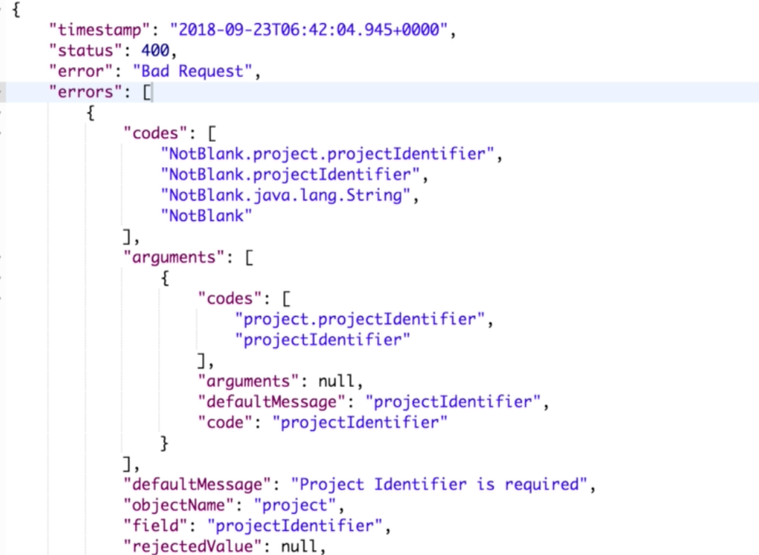

It is still not that good, we want to make it more clear.

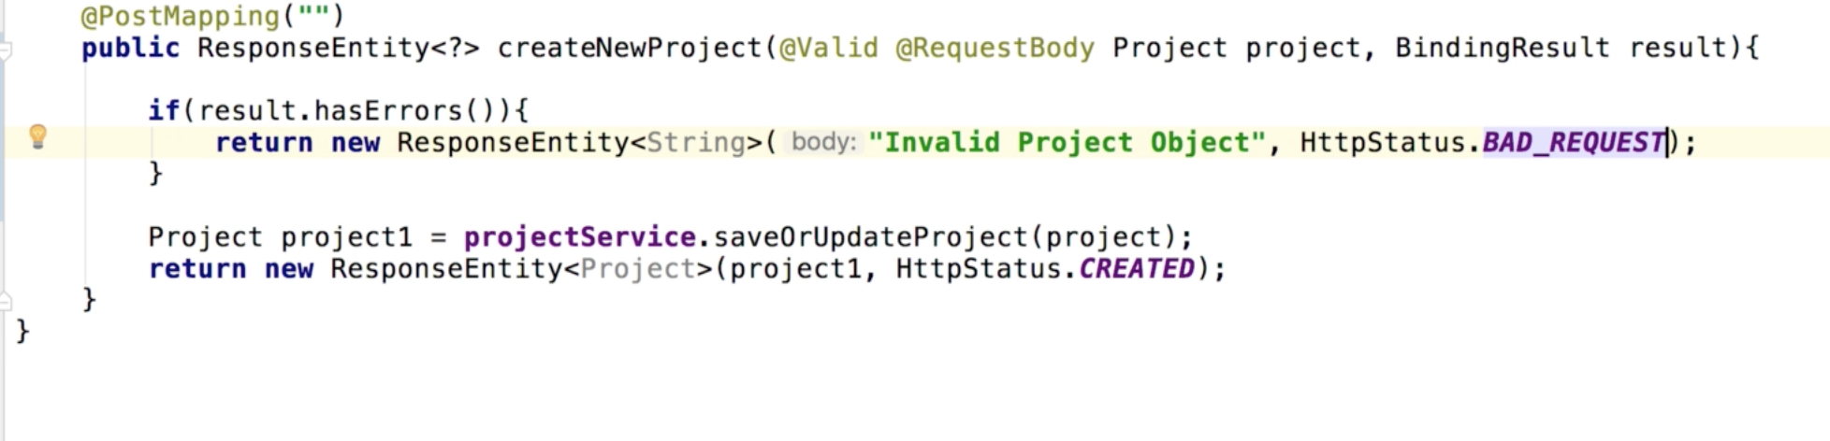

So BindingResult is the analysis of your response, if here are any errors, we can return customized message to front end.

## Project object validation part 2

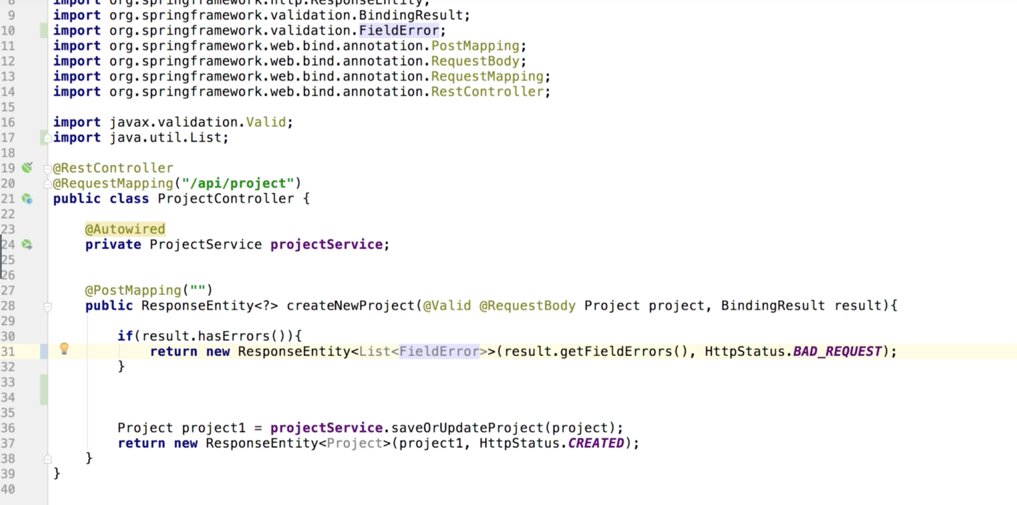

we still don’t want to only return a simple string, based on the BindingResult doc, the getFieldErrors() method would give us a list of field errors.

Actually the returning response is exactly same as we add the result.hasErrors() if statement before.

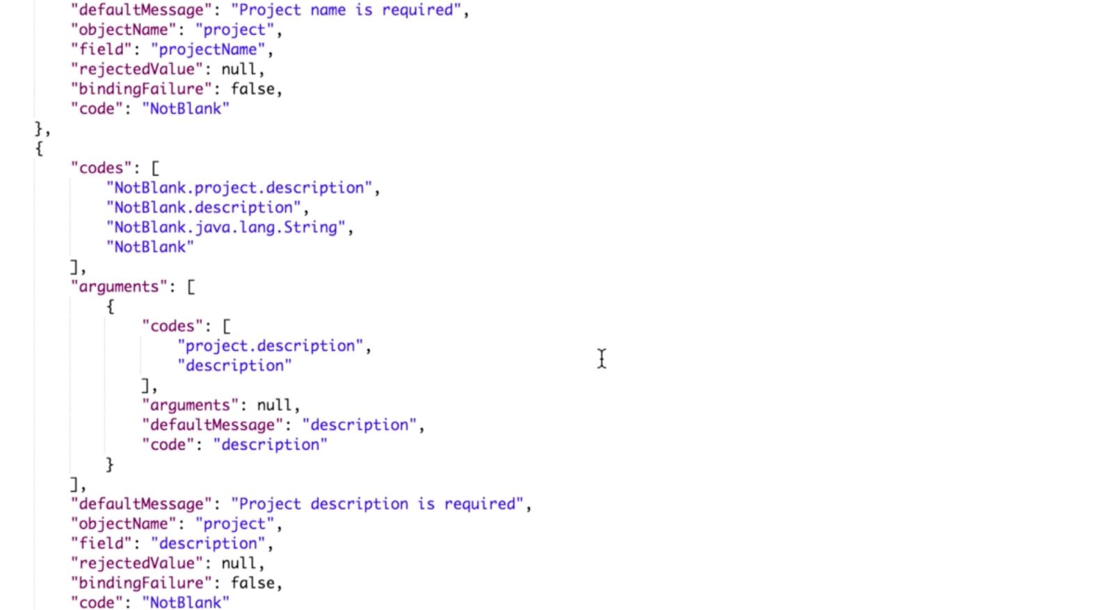

We want to see the field and the default message. 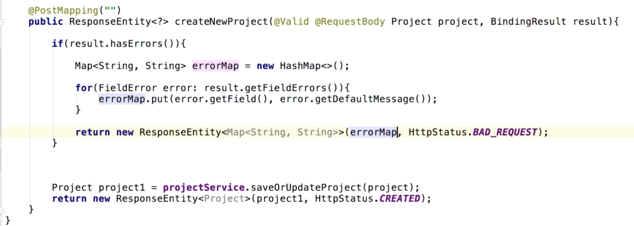

The return would be like:

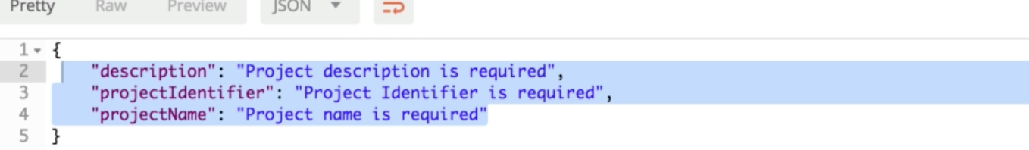

## Reactor Project Controller

Since we are gonna perform that validation to other controllers.

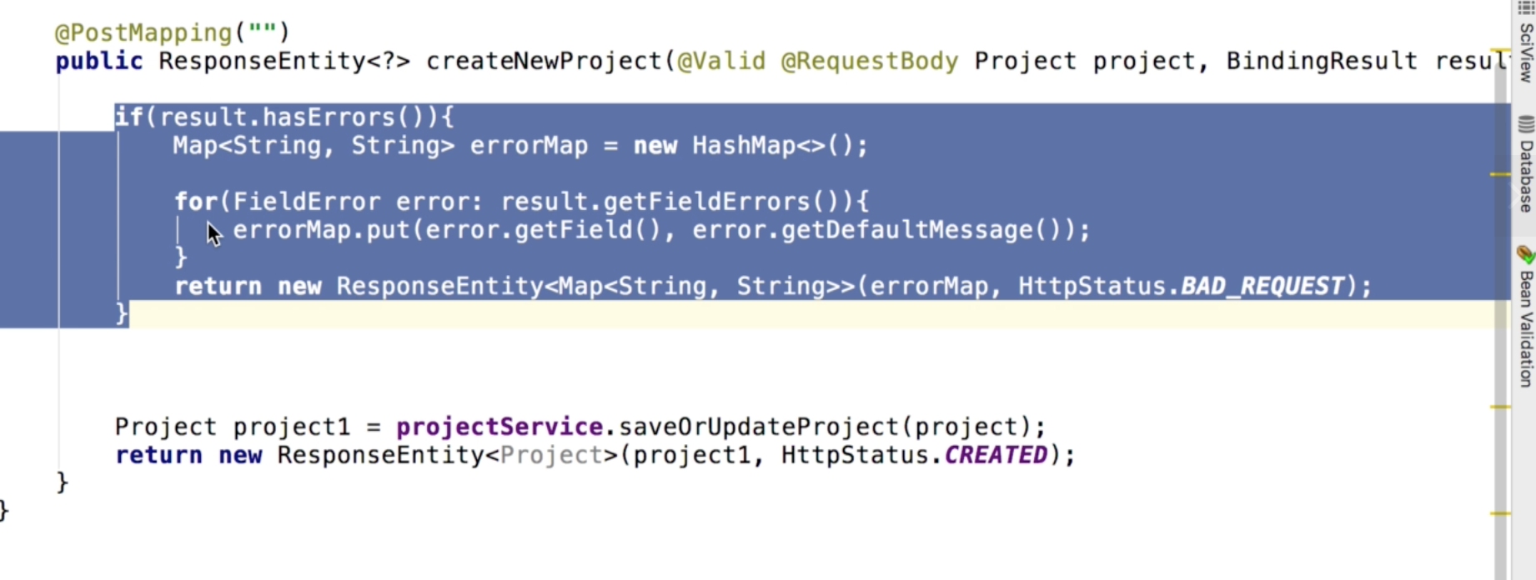

We can extract the code to a private method.

But the practice provided in the tutorial is extracted as a service.

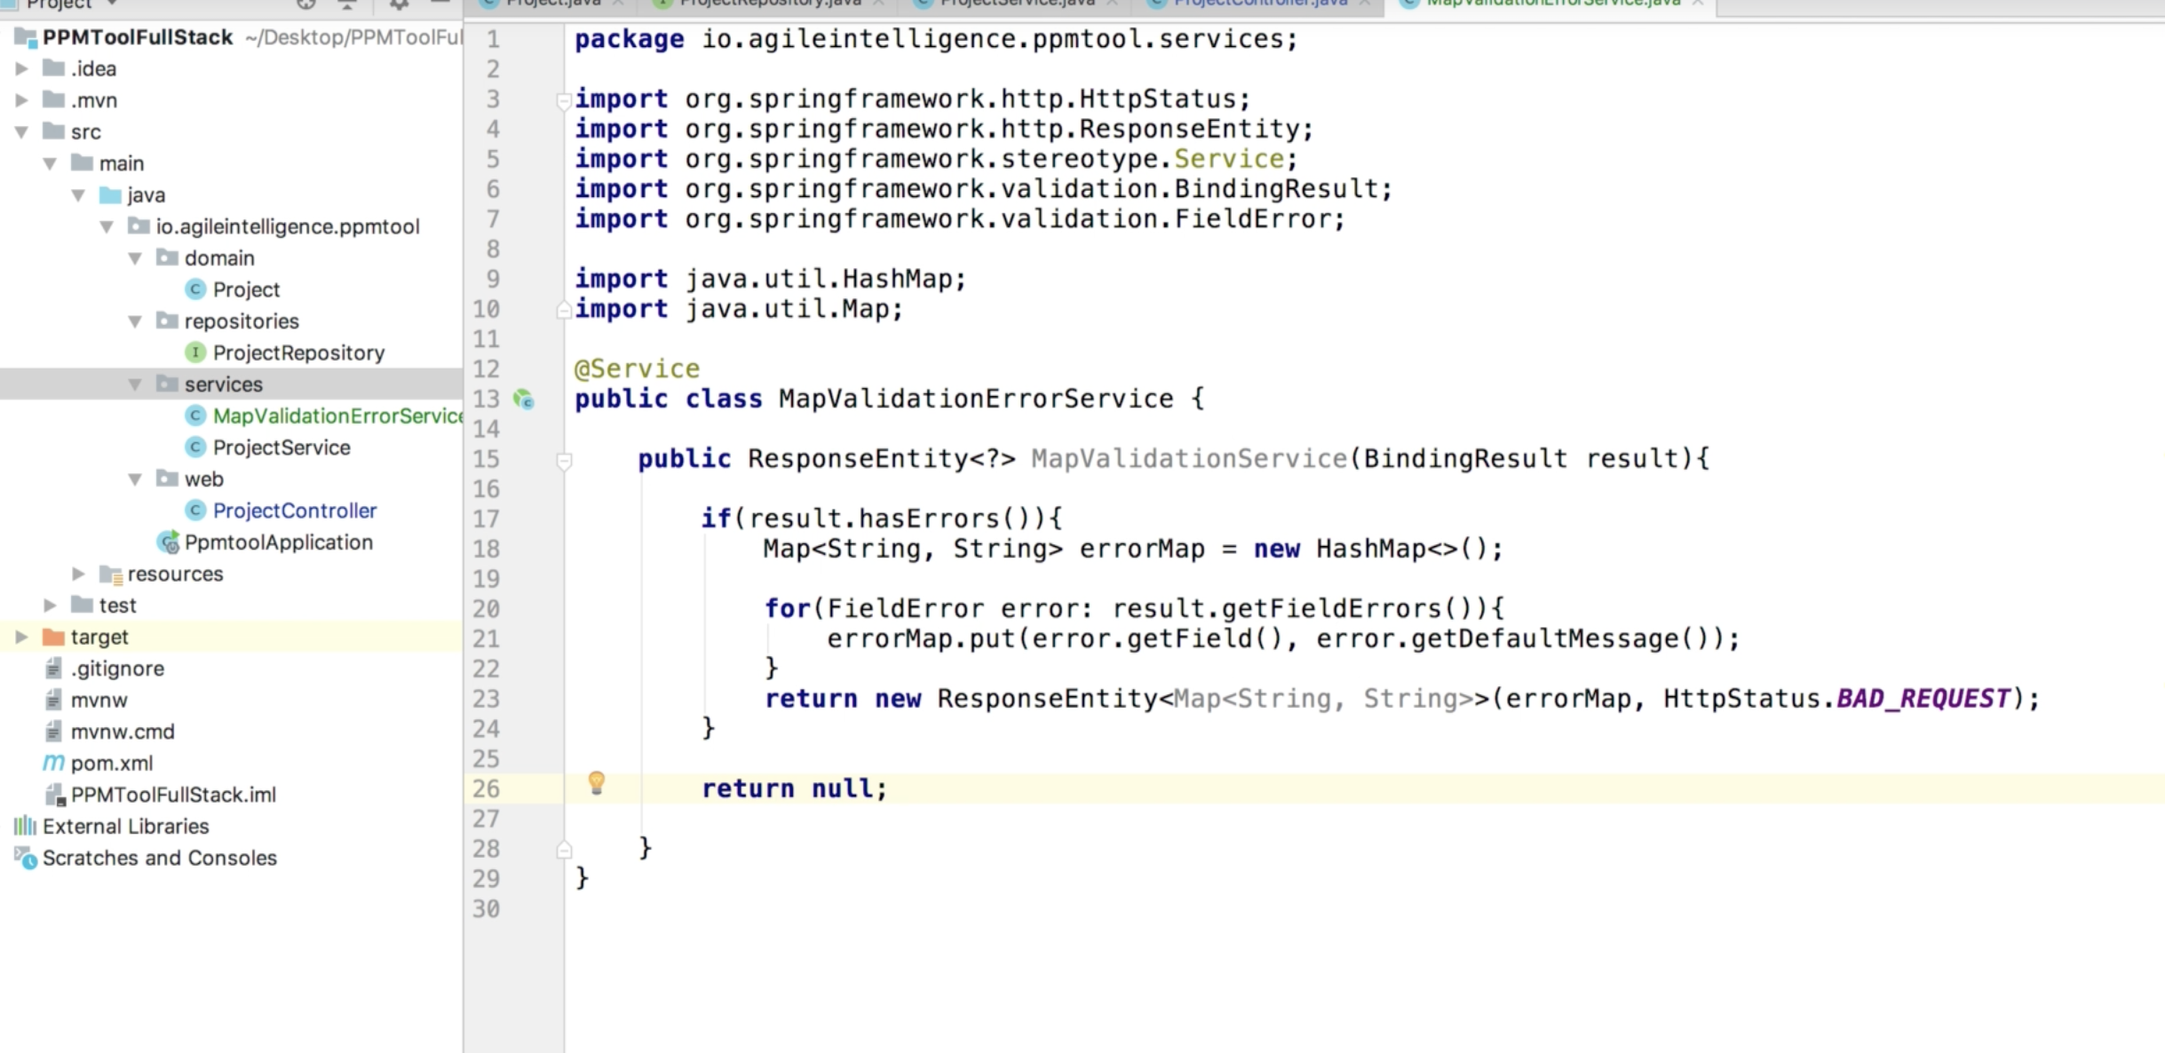

All we need to do in controller is import the service and use it.

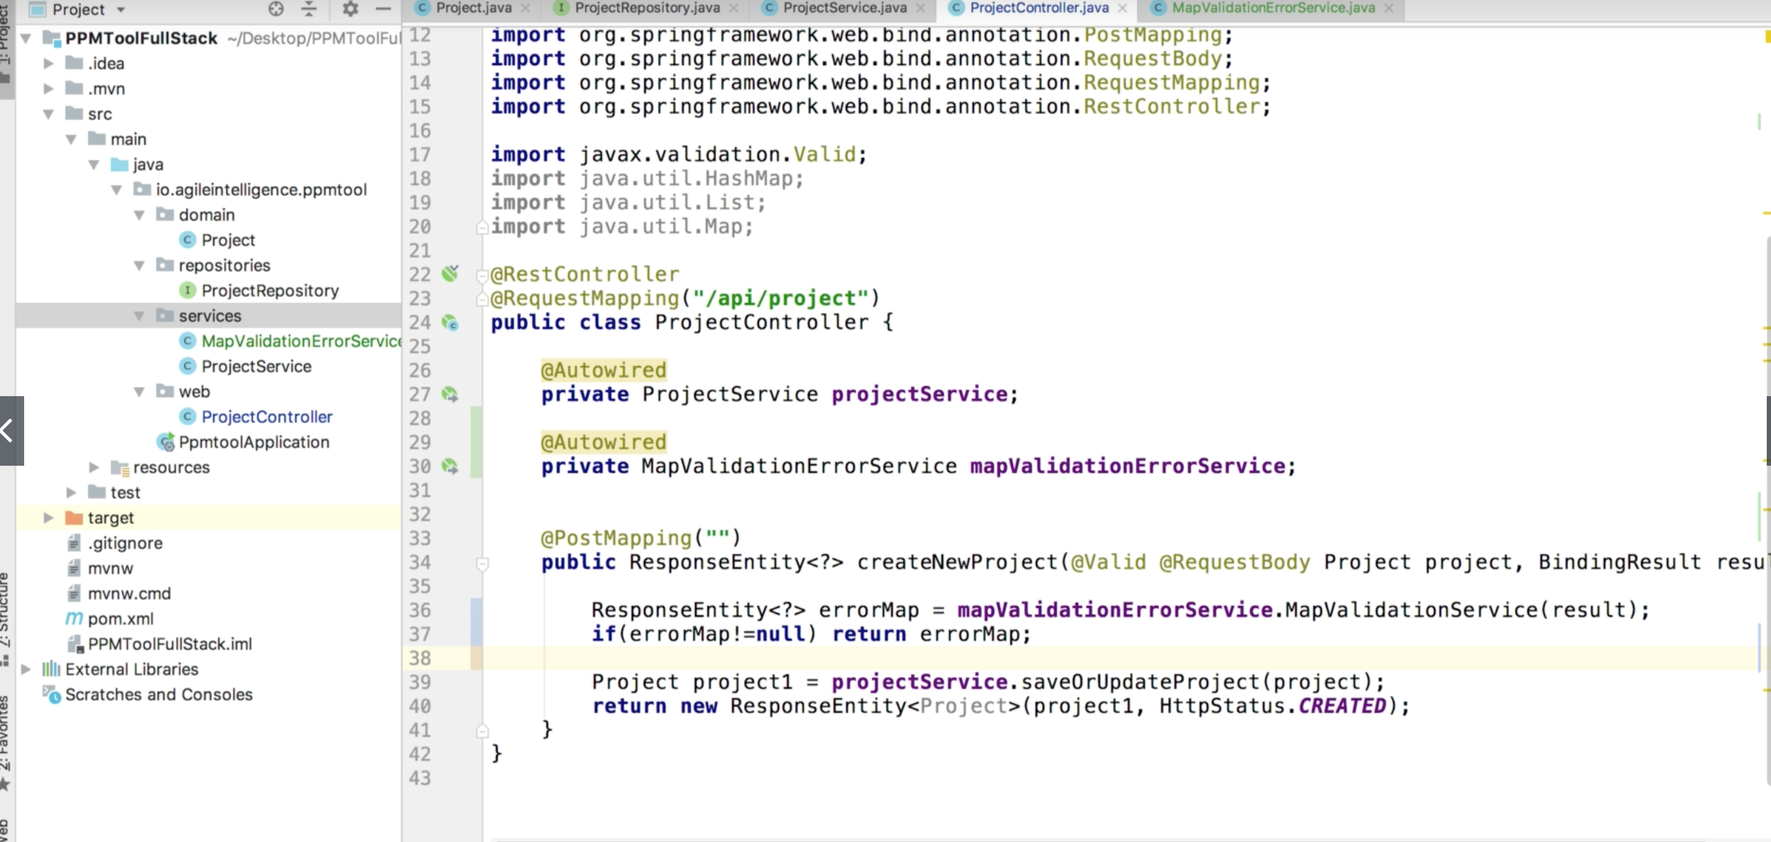

Now if we create a project with existed project identifier, the server would give us

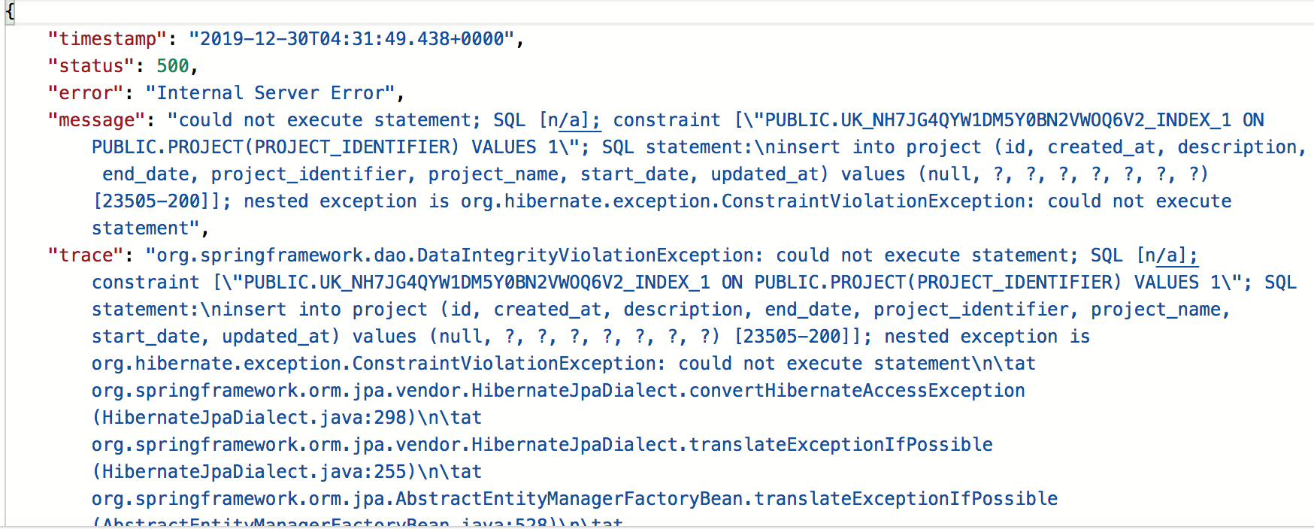

next lecture we would custom the exception been thrown for unique project identifier.

## Custom Exception for unique project identifier

The reason why the duplicate project identifier is not detected by the MapValidationErrorService is it has went through our MapValidationErrorService and the duplication is detected on database manipulation layer, so our service has nothing to do with it.

Let’s see how to resolve it.

Here are several ways to resolve it, we are gonna create custom exception handler.

1. Create new package – exceptions

In the context we are talking about, the exceptions contain three components, exception response, exception handler and exception itself.

1. ProjectIdExceptionResponse

This class is for how we structuring the message.

Basiclly we want the same structure as before

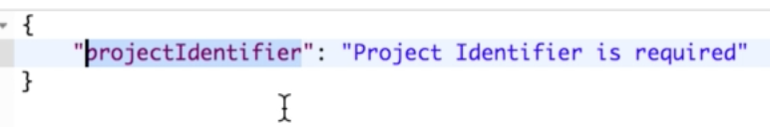

just the message is different, the constructor would take a string and set it as the object value.

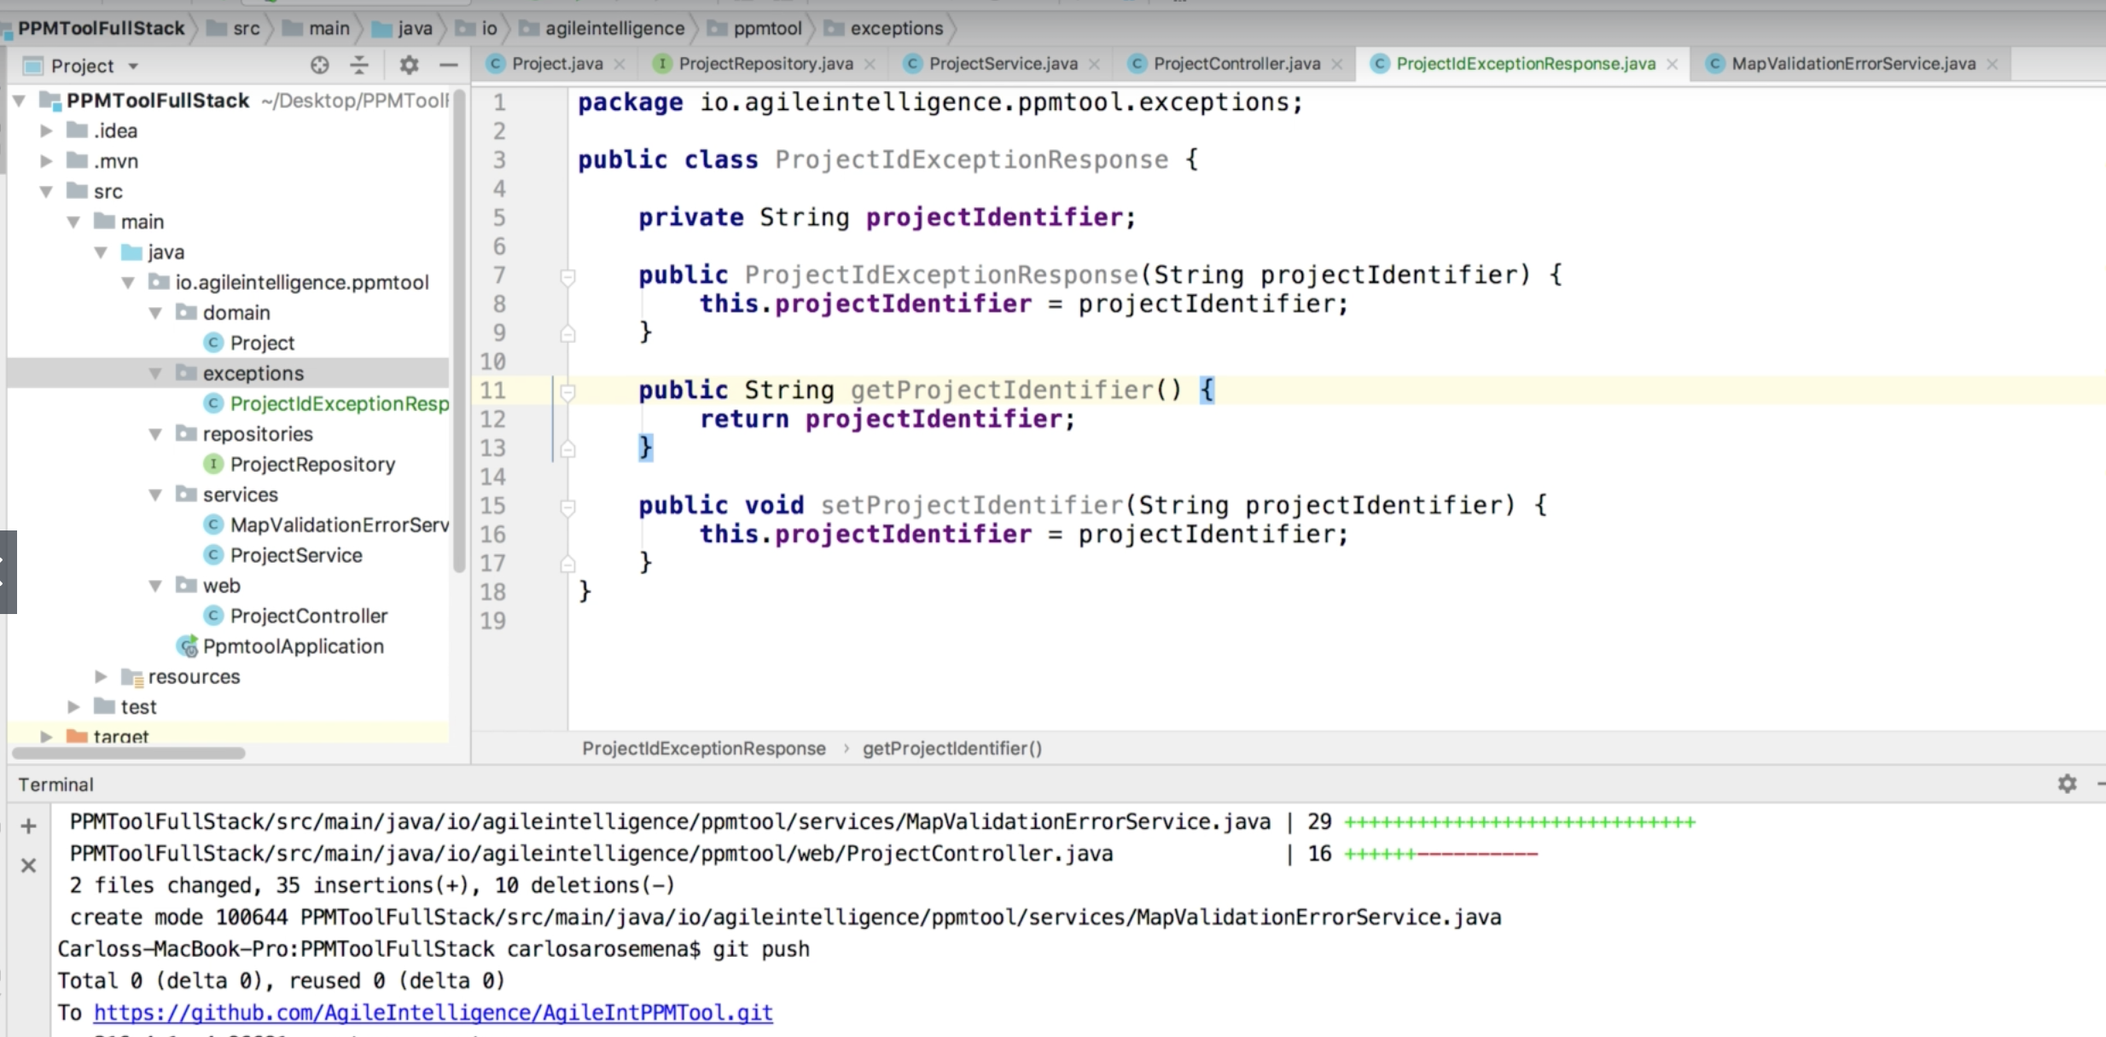

1. ProjectIdException

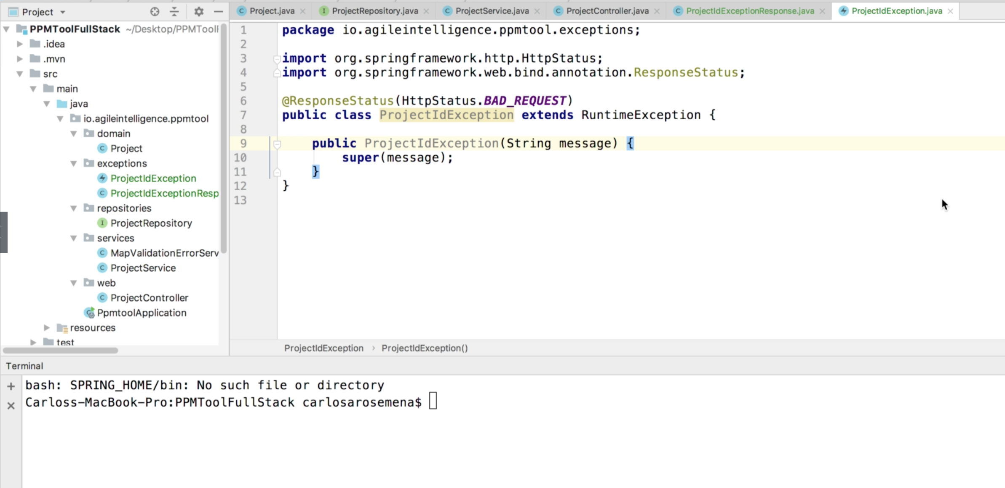

Here we create the exception class itself.

1. Response Exception Handler

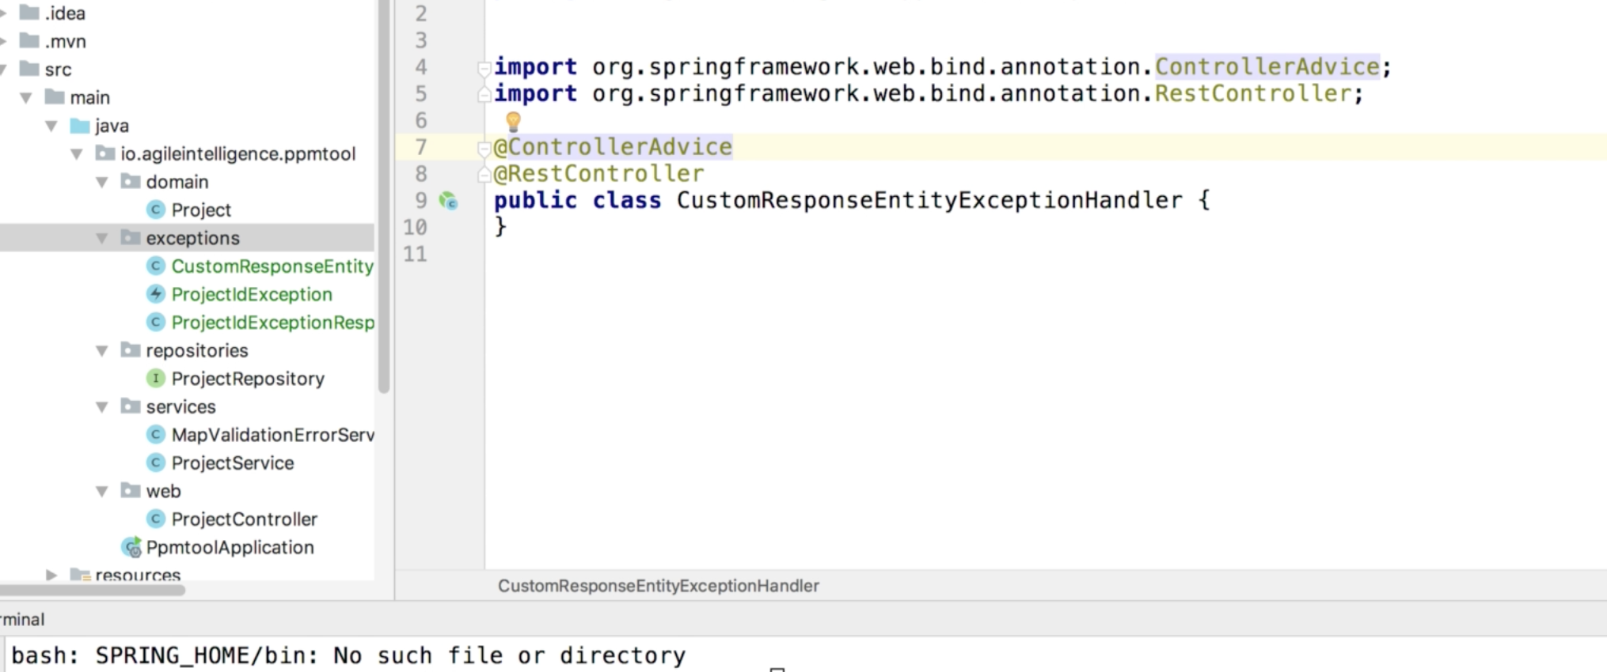

Controller Advice is a mechanism to let you have exception handlers that are controller specific. Help you match exception declaration with exception handler, also gives you a global exception handling for controller.

**Question** : @ControllerAdvice makes the other controllers come to this class in case of exception. But not clear about @RestController here.

**Answer**: @ControllerAdvice is an annotation that allows you to write global code that can be applied to controllers. In our use-case, we are using this for exception handling. @ControllerAdvice applies to all classes that use the @Controller annotation (which as you know extends to classes using @RestController)

That being said, the **CustomResponseEntityExceptionHandler**class  also provides a response a response back in case of exceptions. This is the main reason why it needs to be annotated with @RestController

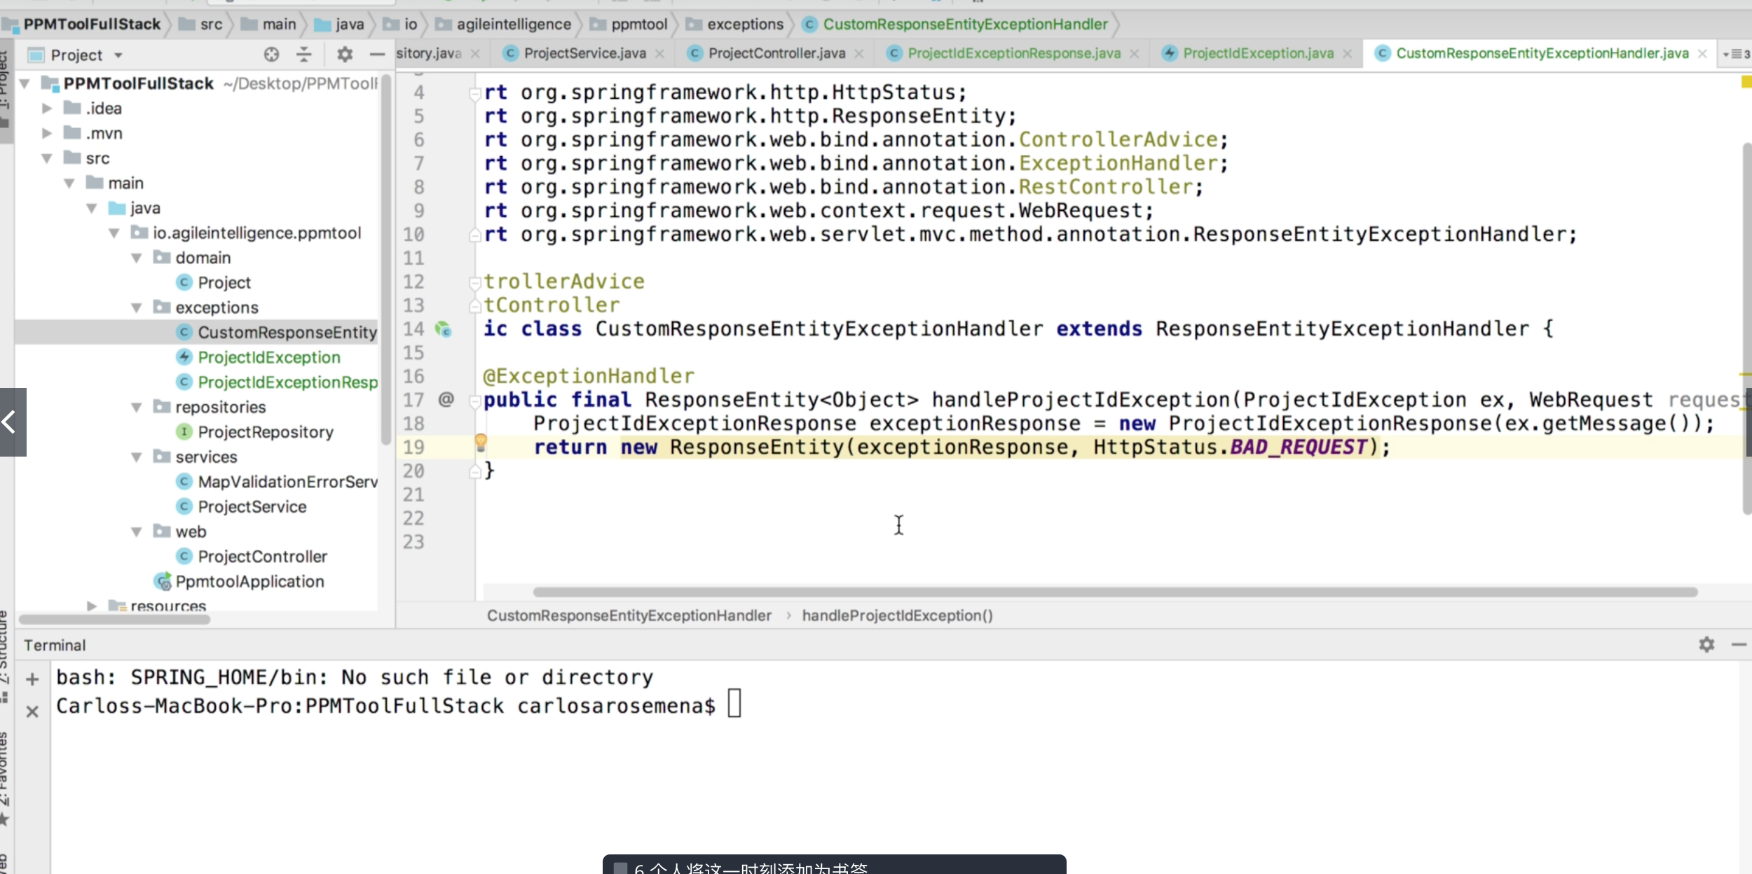

Basically we are creating that response using projectIdException predefined and return it as ResponseEntity as before.

Now we need to put the handler to where the exception be cast, that is the project service layer.

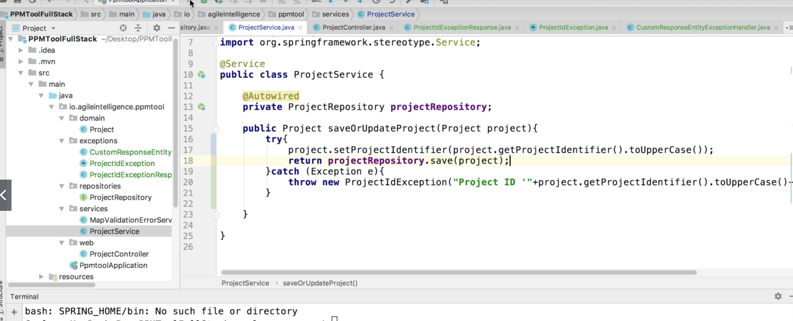

Basically in the project service layer, if the project identifier has existed, we would throw the exception, and the exception handler would handle it as the way we specified.

The reason why we make the identifier all uppercase is we want to remove the ambiguity so that it would be easier to look up a specific project or serialize/deseralize the object.